From: https://www.gq.com/story/sperm-count-zero
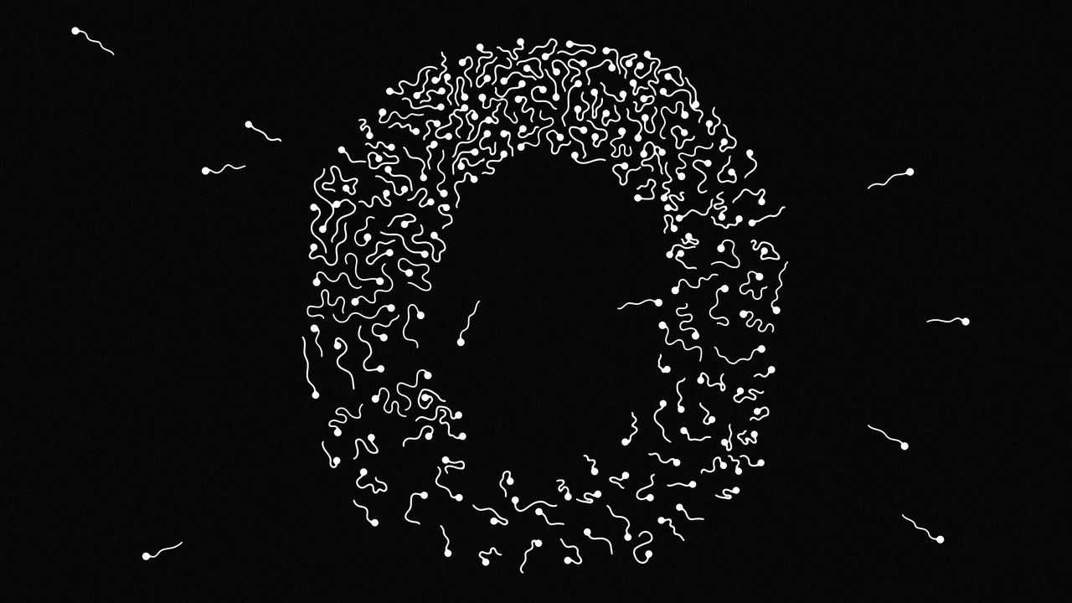

Best of GQ

Sperm Count Zero
BY
DANIEL NOAH HALPERN
2 days ago
A strange thing has happened to men over the past few decades: We’ve become increasingly infertile, so much so that within a generation we may lose the ability to reproduce entirely. What’s causing this mysterious drop in sperm counts—and is there any way to reverse it before it’s too late?
Men are doomed. Everybody knows this. We're obviously all doomed, the women too, everybody in general, just a waiting game until one or another of the stupid things our stupid species is up to finally gets us. But as it turns out, no surprise: men first. Second instance of no surprise: We're going to take the women down with us.
There has always been evidence that men, throughout life, are at higher risk of early death—from the beginning, a higher male incidence of Death by Mastodon Stomping, a higher incidence of Spiked Club to the Brainpan, a statistically significant disparity between how many men and how many women die of Accidentally Shooting Themselves in the Face or Getting Really Fat and Having a Heart Attack. The male of the species dies younger than the female—about five years on average. Divide a population into groups by birth year, and by the time each cohort reaches 85, there are two women left for every man alive. In fact, the male wins every age class: Baby boys die more often than baby girls; little boys die more often than little girls; teenage boys; young men; middle-aged men. Death champions across the board.
Now it seems that early death isn't enough for us—we're on track instead to void the species entirely. Last summer a group of researchers from Hebrew University and Mount Sinai medical school published a study showing that sperm counts in the U.S., Europe, Australia, and New Zealand have fallen by more than 50 percent over the past four decades. (They judged data from the rest of the world to be insufficient to draw conclusions from, but there are studies suggesting that the trend could be worldwide.) That is to say: We are producing half the sperm our grandfathers did. We are half as fertile.
The Hebrew University/Mount Sinai paper was a meta-analysis by a team of epidemiologists, clinicians, and researchers that culled data from 185 studies, which examined semen from almost 43,000 men. It showed that the human race is apparently on a trend line toward becoming unable to reproduce itself. Sperm counts went from 99 million sperm per milliliter of semen in 1973 to 47 million per milliliter in 2011, and the decline has been accelerating. Would 40 more years—or fewer—bring us all the way to zero?
I called Shanna H. Swan, a reproductive epidemiologist at Mount Sinai and one of the lead authors of the study, to ask if there was any good news hiding behind those brutal numbers. Were we really at risk of extinction? She failed to comfort me. “The What Does It Mean question means extrapolating beyond your data,” Swan said, “which is always a tricky thing. But you can ask, ‘What does it take? When is a species in danger? When is a species threatened?’ And we are definitely on that path.” That path, in its darkest reaches, leads to no more naturally conceived babies and potentially to no babies at all—and the final generation of Homo sapiens will roam the earth knowing they will be the last of their kind.

If we are half as fertile as the generation before us, why haven't we noticed? One answer is that there is a lot of redundancy built into reproduction: You don't need 200 million sperm to fertilize an egg, but that's how many the average man might devote to the job. Most men can still conceive a child naturally with a depressed sperm count, and those who can't have a booming fertility-treatment industry ready to help them. And though lower sperm counts probably have led to a small decrease in the number of children being conceived, that decline has been masked by sociological changes driving birth rates down even faster: People in the developed world are choosing to have fewer children, and they are having them later.
The problem has been debated among fertility scientists for decades now—studies suggesting that sperm counts are declining have been appearing since the '70s—but until Swan and her colleagues' meta-analysis, the results have always been judged incomplete or preliminary. Swan herself had conducted smaller studies on declining sperm counts, but in 2015 she decided it was time for a definitive answer. She teamed up with Hagai Levine, an Israeli epidemiologist, and Niels Jørgensen, a Danish endocrinologist, and along with five others, they set about performing a systematic review and meta-regression analysis—that is, a kind of statistical synthesis of the data. “Hagai is a very good scientist, and he also used to be the head of epidemiology for the Israeli armed forces,” Swan told me. “So he's very good at organizing.” They spent a year working with the data.
“We should hope for the best and prepare for the worst,” said Hagai Levine, a lead author of the study. “And that is the possibility that we will become extinct.”
The results, when they came in, were clear. Not only were sperm counts per milliliter of semen down by more than 50 percent since 1973, but total sperm counts were down by almost 60 percent: We are producing less semen, and that semen has fewer sperm cells in it. This time around, even scientists who had been skeptical of past analyses had to admit that the study was all but unassailable. Jørgensen, in Copenhagen, told me that when he saw the results, he'd said aloud, “No, it cannot be true.” He had expected to see a past decline and then a leveling off. But he couldn't argue when the team ran the numbers again and again. The downward slope was unwavering.
Almost all the scientists I talked to stressed that not only were low sperm counts alarming for what they said about the reproductive future of the species—they were also a warning of a much larger set of health problems facing men. In this view, sperm production is a canary in the coal mine of male bodies: We know, for instance, that men with poor semen quality have a higher mortality rate and are more likely to have diabetes, cancer, and cardiovascular disease than fertile men.
Testosterone levels have also dropped precipitously, with effects beginning in utero and extending into adulthood. One of the most significant markers of an organism's sex is something called anogenital distance (AGD)—the measurement between the anus and the genitals. Male AGD is typically twice the length of female, a much more dramatic difference than height or weight or musculature. Lower testosterone leads to a shorter AGD, and a measurement lower than the median correlates to a man being seven times as likely to be subfertile and gives him a greater likelihood of having undescended testicles, testicular tumors, and a smaller penis. “What you are seeing in a number of systems, other developmental systems, is that the sex differences are shrinking,” Swan told me. Men are producing less sperm. They're also becoming less male.
I assumed that the next thing Swan was going to tell me was that these changes were all a mystery to scientists. If only we could figure out what was causing the drop in sperm counts, I imagined, we could solve all the attendant health problems at once. But it turns out that it's not a mystery: We know what the culprit is. And it's hiding in plain sight.

The sixth floor of the Rigshospitalet, a hospital and research institution in Copenhagen, houses the Department of Growth and Reproduction. The babies are all a few floors downstairs—on six, the unit is populated not with new parents but with doctors and researchers hunched over mass spectrometers and gel imagers and the like. I was there to meet Niels E. Skakkebæk, an 82-year-old pediatric endocrinologist, who founded the department in 1990. After walking me through the lab, he showed me to his office, a cramped, closet-like space—modest for someone who is a giant in his field. Male fertility and male reproductive health, Skakkebæk told me, are in full-blown crisis. “Here in Denmark, there is an epidemic of infertility,” he said. “More than 20 percent of Danish men do not father children.”
Skakkebæk first suspected something was going wrong in the late '70s, when he treated an infertile patient with an abnormality in the cells of the testes that he had never seen before. When he treated a second man with the same abnormality a few years later, he began to investigate a connection. What he found was a new form of precursor cells for testicular cancer, a once rare disease whose incidence had doubled. Moreover, these precursor cells had begun developing before the patient was even born. “He had the insight that testicular cancer, which is a cancer of young men, is something that is actually originated in utero,” Swan told me. And if these testes had somehow been misdeveloping in utero, Skakkebæk asked himself, what else was happening to these babies before they were born?
Eventually, Skakkebæk linked several other previously rare symptoms for a condition he called testicular dysgenesis syndrome (TDS), a collection of male reproductive problems that include hypospadias (an abnormal location for the end of the urethra), cryptorchidism (an undescended testicle), poor semen quality, and testicular cancer. What Skakkebæk proposed with TDS is that these disorders can have a common fetal origin, a disruption in the development of the male fetus in the womb.
So what was causing this disruption? To say there is only a single answer might be an overstatement—stress, smoking, and obesity, for example, all depress sperm counts—but there are fewer and fewer critics of the following theory:
- The industrial revolution happened.
- And the oil industry happened.
- And 20th-century chemistry happened.
In short, humans started ingesting a whole host of compounds that affected our hormones—including, most crucially, estrogen and testosterone.
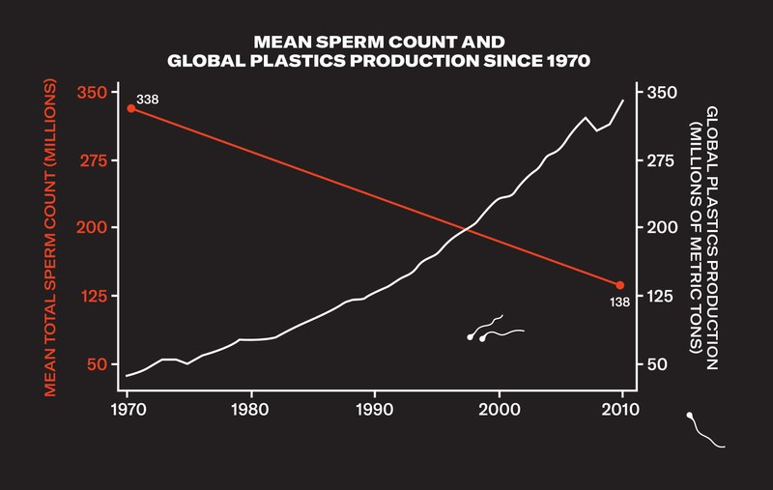
The scientists I talked to were less cautious about embracing this explanation than I expected. Down the hall from Skakkebæk's office, I met Anna-Maria Andersson, a biologist whose research has focused on declining testosterone levels. “There has been a chemical revolution going on starting from the beginning of the 19th century, maybe even a bit before,” she told me, “and upwards and exploding after the Second World War, when hundreds of new chemicals came onto the market within a very short time frame.” Suddenly a vast array of chemicals were entering our bloodstream, ones that no human body had ever had to deal with. The chemical revolution gave us some wonderful things: new medicines, new food sources, faster and cheaper mass production of all sorts of necessary products. It also gave us, Andersson pointed out, a living experiment on the human body with absolutely no forethought to the result.
When a chemical affects your hormones, it's called an endocrine disruptor. And it turns out that many of the compounds used to make plastic soft and flexible (like phthalates) or to make them harder and stronger (like Bisphenol A, or BPA) are consummate endocrine disruptors. Phthalates and BPA, for example, mimic estrogen in the bloodstream. If you're a man with a lot of phthalates in his system, you'll produce less testosterone and fewer sperm. If exposed to phthalates in utero, a male fetus's reproductive system itself will be altered: He will develop to be less male.
Women with raised levels of phthalates in their urine during pregnancy were significantly more likely to have sons with shorter anogenital distance as well as shorter penis length and smaller testes. “When the [fetus's] testicles start making testosterone, which is about week eight of pregnancy, they make a little less,” Swan said. “That's the nub of this whole story. So phthalates decrease testosterone. The testicles then do not produce proper testosterone, and the anogenital distance is shorter.”
The problem is that these chemicals are everywhere. BPA can be found in water bottles and food containers and sales receipts. Phthalates are even more common: They are in the coatings of pills and nutritional supplements; they're used in gelling agents, lubricants, binders, emulsifying agents, and suspending agents. Not to mention medical devices, detergents and packaging, paint and modeling clay, pharmaceuticals and textiles and sex toys and nail polish and liquid soap and hair spray. They are used in tubing that processes food, so you'll find them in milk, yogurt, sauces, soups, and even, in small amounts, in eggs, fruits, vegetables, pasta, noodles, rice, and water. The CDC determined that just about everyone in the United States has measurable levels of phthalates in his or her body—they're unavoidable.
What's more, there is evidence that the effect of these endocrine disruptors increases over generations, due to something called epigenetic inheritance. Normally, acquired traits—like, say, a sperm count lowered by obesity—aren't passed down from father to son. But some chemicals, including phthalates and BPA, can change the way genes are expressed without altering the underlying genetic code, and that change is inheritable. Your father passes along his low sperm count to you, and your sperm count goes even lower after you're exposed to endocrine disruptors. That's part of the reason there's been no leveling off even after 40 years of declining sperm counts—the baseline keeps dropping.

With all due respect to Dr. Swan and the problems of extrapolating beyond one's data, I wanted to get back to What It All Means. The answer, I thought, might be found at the 13th International Symposium on Spermatology, which took place in May, on Lidingö, a small island in the inner Stockholm archipelago. A hundred spermatologists in one place: You'd think (incorrectly) that the jokes would be good. Skakkebæk had told me I'd be able to find some dissenters to the conclusions of Swan's meta-analysis there, but what I witnessed instead was the final vanquishing of the few remaining doubters.
At the welcome dinner (reindeer and rooster), I met Hagai Levine, the Israeli co-author of the Hebrew University/Mount Sinai meta-analysis. Levine, who is 40, told me we had reasons to worry. “I'm saying that we should hope for the best and prepare for the worst,” he said. “And that is the possibility that we will become extinct. That's a possibility we must seriously consider. I'm not saying it's going to happen. I'm not saying it's likely to happen. I'm not saying that's the prediction. I'm just saying we should be prepared for such a possibility. That's all. And we are not.”
His session the next morning—“Are Spermatozoa at the Verge of Extinction?”—would be the defining event of the conference: It cast a shadow over all the other talks. At a panel discussion that followed his presentation, Levine continued his argument for addressing the causes of the crisis, saying, “My default, if I don't know, is that it is up to the manufacturers of chemicals to prove that their chemicals are safe. But I don't feel like I need any more evidence to take action with chemicals already known to disrupt the endocrine system.”
The organizer of the symposium, Lars Björndahl, a Swedish spermatologist who had presented earlier in the morning, urged caution. “I have great respect for epidemiological studies, but we should remember that mathematical correlations don't prove that there is a causative relation,” he said. Questions from the audience—often taking the form of statements—were much along the same lines: Be careful of a bias toward the assumption that all these things are connected. Levine nodded with only a hint of chagrin, like a patient professor waiting hopefully for his students to catch up.
David Mortimer, who runs a company that designs and establishes assisted-conception laboratories, was one of the only members of the audience willing to question Levine's study itself. He pointed out that methods for measuring sperm had changed dramatically over the time period of the study and that the old studies were profoundly unreliable.
Levine was ready with an answer. “So that's one of the reasons we also conducted a sensitivity analysis,” he said from the stage, “with studies with sample collection only after 1995—and the slope was even steeper. So that could not explain the decline we see after 1995.”
“I've never said there was no decline in sperm counts,” Mortimer said, a bit defensively. Levine, who had been so gracious and engaged with his critics, began to look a little tired. He rallied, though, when the group agreed to put out a joint statement about the crisis. The chairs of the symposium called on the world to acknowledge that male reproductive health was essential for the survival of the species, that its decline was alarming and should be studied, and that at present it was being neglected in funding and attention.
Mortimer came around and ended up signing the statement. When I caught up with him later, he wasn't nearly as dismissive of the study's conclusions as I expected. He agreed there was little question that sperm counts were dropping, and he even embraced some of the direst predictions of scientists like Levine. “The epigenetics are the scary bit,” he told me, “because what we're doing now affects the future of the human race.” When even the skeptics are scared, it's probably time to pay attention.

Can anything be done? Over the past 20 years, there have been occasional attempts to limit the number of endocrine disruptors in circulation, but inevitably the fixes are insubstantial: one chemical removed in favor of another, which eventually turns out to have its own dangers. That was the case with BPA, which was partly replaced by Bisphenol S, which might be even worse for you. The chemical industry, unsurprisingly, has been resistant to the notion that the billions of dollars of revenue these products represent might also represent terrible damage to the human body, and have often followed the model of Big Tobacco and Big Oil—fighting regulation with lobbyists and funding their own studies that suggest their products are harmless. The website for the American Chemistry Council, an industry trade association, has a page dedicated to phthalates that mostly consists of calling Shanna Swan's research “controversial” and asserting that her “use of methodologies that have not been validated and unconventional data analysis have been criticized by the scientific community.” (Cited critics of Swan include Elizabeth Whelan, now deceased, an epidemiologist famous for fighting the regulation of chemicals from her position as president of the American Council on Science and Health, which has received funding from Chevron, DuPont, and other companies in the plastic business.)
Assuming that we're unable to wean ourselves off plastics and other marvels of modern science, we may be stuck innovating our way out of this mess. How long we're able to outrun the drop in sperm count may depend, finally, on how good we get at IVF and other fertility treatments. When I spoke with Marc Goldstein, a urologist and surgeon at Weill Cornell medical center in New York City, he said that while there was “no question I've seen a big increase in men with male-factor infertility,” he wasn't worried for the future of the species. Assisted reproduction would keep the babies coming, no matter how sickly men's sperm become.
It's true that fertility treatments have already given men with extremely low sperm counts the chance to be fathers. Indeed, by looking at their cases, we can glimpse what our low-sperm-count future might look like. We know that it will be arduous to conceive, and expensive—so expensive that having children may no longer be an option available to all couples. A fertility-treatment-dependent future is also unlikely to produce a birth rate anywhere near current levels.
Not long ago, I spoke with Chris Wohl, a research materials/surface engineer at the NASA Langley Research Center in Virginia, who spent six years trying to conceive a child. Both he and his wife had fertility problems: Wohl's sperm count was under 2 million per milliliter—the average count we'd expect to reach, at the current rate, by 2034. “We started in the normal way of trying to have kids,” he said, “and after a few years, we said, ‘Okay, let's talk to some folks.’ ” They went through several rounds of intrauterine insemination. “And then after that sixth time, we said, ‘This isn't working. We need to kind of up our technology game.’ So we went to a reproductive endocrinologist and went through several rounds of IVF. And then when that failed, we were going to look into adoption. That's when somebody came forward and said that they would be a surrogate for us.” Finally, with the surrogate, the process worked. He and his wife now have a healthy, strong-willed 4-year-old girl.
So perhaps that's the solution: As long as we hover somewhere above Sperm Count Zero, and with an assist from modern medicine, we have a shot. Men will continue to be essential to the survival of the species. The problem with innovation, though, is that it never stops. A new technology known as IVG—in vitro gametogenesis—is showing early promise at turning embryonic stem cells into sperm. In 2016, Japanese scientists created baby mice by fertilizing normal mouse eggs with sperm created via IVG. The stem cells in question were taken from female mice. There was no need for any males.
Daniel Noah Halpern wrote about the Singularity in the November 2014 issue.
This story originally appeared in the September 2018 issue with the title "Sperm Count Zero."

